***News Bulletin - June 24***

***Welcome***

Since the last newsletter, Dr Dawoud and his wife have become proud parents to their beautiful baby daughter born on the 13th of February 2024.



***Farewell***

We say farewell and good luck to Dr Mehboob who has now relocated to the Isle of Man. She will be very much missed by all, and we wish Dr Mehboob all the very best for the future.

***Congratulations***

Well, done to Rachel who is now a fully qualified Practice Nurse! Rachel has worked very hard completing her Nursing degree and qualified on 1st April 24. We are all very proud of her achievement.



[This Photo](https://www.pngall.com/graduation-cap-png/download/39673) by Unknown Author is licensed under [CC BY-NC](https://creativecommons.org/licenses/by-nc/3.0/)

***Appointments***

From the 1st of April there have been new changes made to the appointment booking system, that we believe will improve patients’ accessibility to booking appointments.

* More appointments have become available to pre-book online.
* Patients will not be asked to call back at 1pm for appointments.
* All urgent on the day appointments are released at 8am for both the morning and afternoon clinics.
* On the day appointments are now used for urgent only appointments, anything else can be pre-booked, over the phone or on-line.

If you do not have an urgent need of care, our receptionists are Care Navigators, and they may pre-book you an appointment or refer you to the minor alignment scheme.

For further details, please view the link - <https://www.nhs.uk/nhs-services/pharmacies/how-pharmacies-can-help/>

The NHS App allows you to book appointments. Nurse appointments are available to book online. If you are due your annual health check on your birthday month, you can directly book an appointment on-line.

The nursing team offer free NHS Health Checks for over 40’s, carers health checks and weight management support. If you are interested in attending one of these appointments, please contact the surgery. Appointments are also available to book online via the NHS App.

Once a month, the surgery offers Saturday Increased access appointments with a GP, Nurse, and HCA. If you require a Saturday appointment, please speak to Reception team or email the surgery for further information. The surgery email address is [Lscicb-csr.drhamad@nhs.net](mailto:Lscicb-csr.drhamad@nhs.net)

If you need support in downloading the NHS App, please speak to our Office Manager Joanna.



***Ordering Prescriptions/Prescription Line***

The surgery allows medication orders for patients on the telephone who are:

* Aged 65 or over.
* A carer.
* Living in a nursing home.
* Have a disability.

The prescription line is open 10am till 12.30pm Monday to Friday. Please note – The team will NOT accept prescription orders out of these times, and for anybody who does not meet the criteria.

Medication orders can be emailed to the surgery which is monitored and actioned throughout our working hours (Monday to Friday 8am-6.30pm). Please enter your name, date of birth and the medication’s you require. Please note – Prescriptions take 48 hours to process. We would suggest ordering your prescriptions with 5 days’ supply left to ensure it is done in a timely manner.

The NHS App allows patients to directly order their repeat medication to our system for the GP to review and action.

If you are stable on your medication and you are up to date with your annual health checks, you may be eligible for the **Repeat dispensing scheme**, the GP will send six-months’ worth off medication to the pharmacy of your choice. This allows you to collect your medication each month without having to order from your GP.



***Travelling abroad?***

Our Practice Nurse Michelle offers travel vaccination appointments on

Mondays and Tuesday’s. If you have plans of travelling abroad, please complete our online travel questionnaire form on our website.

***Patient Participation Group (PPG) Meeting***

The next meeting will be held on ***Tuesday 11th June 2.30pm-3.30pm*** at the surgery.

We value patients feedback on how we are performing and how we can improve the services we offer to our patients.

We need our patients’ perspective; we need you to share your ideas with us!

If you are interested in joining our PPG, please speak to Joanna our Office Manager for further information.

Patients that join our PPG will be emailed on occasions with surgery updates, questionnaires/feedback forms, invitations to join virtual teams’ meetings or meetings at the surgery.

If at any point you change your mind and decide to leave the PPG, please inform the Office Manager Joanna.

We hope that the PPG meeting will allow our patients to come together and share your recommendations on how we can try to make positive changes.



***DNA’s***

From the 1st of April 2024 to the 31st of April, we have had missed appointments.

Please see appointments missed below:

* Phlebotomy – 12 appointments. 1 hour
* HCA Appointments – 6 appointments. 3 hour
* Nurse Appointments – 16 appointments. 4hr 30 min
* GP Appointments – 16 appointments. 3hrs
* Mental Health Practitioner – 2 appointments. 1.5 hour
* Podiatrist – 1 appointment. 30 min.

This totals of 13.5 hours’ worth of appointments that could have been offered to other patients.

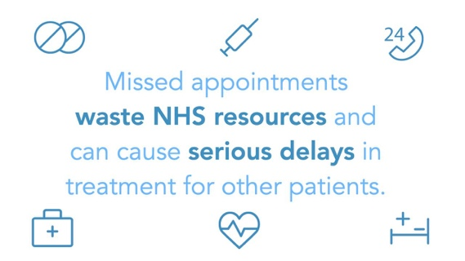If you cannot attend an appointment, please always ***cancel*** it so we can offer the appointment to somebody else.

***Zero tolerance***

The practice fully supports the NHS Zero Tolerance Policy. The aim of this policy is to tackle the increasing problem of violence against staff working in the NHS.

Aggressive behaviour, violent or verbal abuse & bad language will not be tolerated and could result in you being removed from the practice, and in extreme cases, the Police will be contacted if an incident is taking place and there is a threat to staff or other patients.

All incidents will be followed up and you will be sent a formal warning, which may result in you being removed from the practice list.



***One problem per consultation***

At Dr Dawoud’s Surgery, we have a ‘One Problem Per Consultation’ Policy. Please can we kindly ask that all patients stick to this policy.

Please do not be offended if the doctor asks you to rebook for other problems. We always encourage patients to book double appointments if there are multiple problems that need discussing.

Please note – Double appointments may not be available on the day due to the demand of urgent on the day appointments.

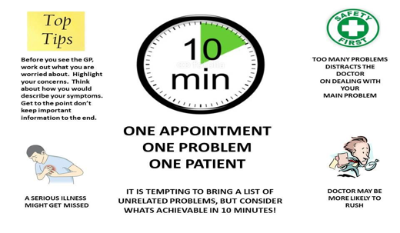

***Bowel Cancer Screening Programme***

The NHS Bowel Cancer Screening kit can detect signs of cancer before you notice anything is wrong.

The kit is automatically posted out to anybody aged 60-74 years and the programme is expanding to make it available to everybody aged 50-59 years.

For more information, please visit <https://www.nhs.uk/conditions/bowel-cancer-screening/>

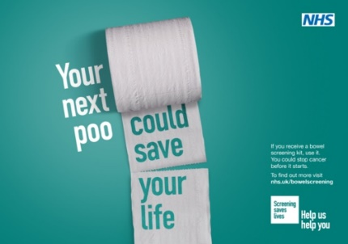

***Cervical Screening***

Cervical screening can help to stop cancer before it starts. Please do not ignore your invite and remind your loved ones to book theirs.

Please contact the surgery to book in for your cervical smear. For more information, please visit <https://www.nhs.uk/conditions/cervical-screening/>



***COVID-19 Vaccination***

If you are eligible for the Spring Booster, please click the link to book this - <https://www.nhs.uk/nhs-services/covid-19-services/covid-19-vaccination-services/book-covid-19-vaccination/>

Please note, the surgery does not deal with the COVID-19 Vaccinations.

***Pharmacy First Service***

Pharmacy now sees patients with more minor ailments, listed below. The surgery may refer you to the pharmacy of your choice to be seen by a member of the pharmacy team to support you in with the below conditions and offer treatments.

For further information, please visit <https://www.nhs.uk/nhs-services/pharmacies/how-pharmacies-can-help/>

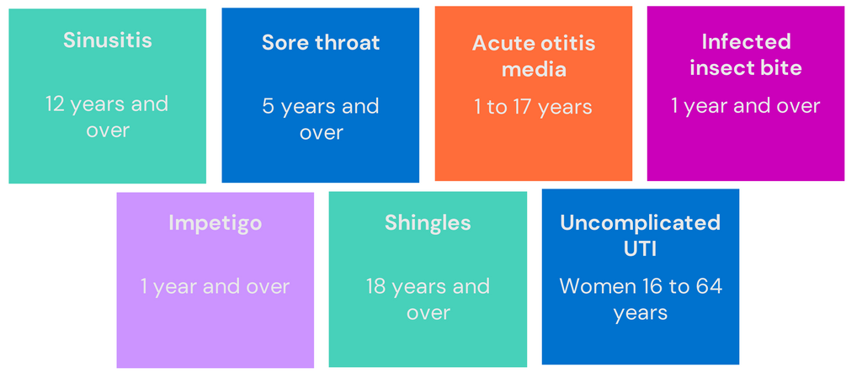

***Surgery Closures***

The surgery will be closed on the dates below, from 1pm for staff training. This means you will be unable to telephone the surgery and our doors will close at 1pm. If you require urgent attention, please contact 111 for their advice or visit our website: [www.drdawoudssurgery.co.uk](http://www.drdawoudssurgery.co.uk) further information is available on our website regarding Surgery closures.

* Tuesday 11th June 2024
* Tuesday 16th July 2024
* Tuesday 17th September 2024
* Tuesday 15th October 2024
* Tuesday 26th November 2024